Mill Creek Youth 2022-2023
Weekly Schedule: Volunteers:
Coffee Shop: 8:30am-9:45am Sammy and Jean Minter (Sunday School)
Worship: 8:30am & 10:45am Jesse and Teresa Witt (Sunday School)
Sunday School: 9:30am-10:30am Debbie McAllister (Wednesday Night)
Wednesday Night: 6:30pm-7:45pm Nikki Cook (Coffee Shop)

Youth Council: Ryan Markham, Cindy Markham, Abby Cook, Maisy Cook, Arron Cook, Josh Witt, Deacon, Witt, Nikki Cook, and Colin Cook.
Youth Calendar (2022-2023):
September (2022) April (2023)
11th Fields of Faith FCA*** 5th No Wednesday Night 28^{Tth} See you at the Pole 7th Good Friday
9th Easter
October (2022) 15th James River Prom
16th Youth Third Sunday Fundraiser 29th Busch Gardens***
22nd Busch Garden’s***
26th Help with Trunk or Treat May (2023)
Service Project (TBA)
November (2022)
12th Solomon’s Mission
23rd No Wednesday Night June (2023)
24th Happy Thanksgiving Putt-Putt Tournament (TBA)

December (2022)
14th Christmas Party July (2023)
16th Last Day of school before Winter Break 7th-11th Centrifuge***
21st No Wednesday Night Kayaking (TBA)
24th Christmas Eve Service
28th No Wednesday Night VBS (TBA)

January (2023) ***= Chaperones Needed
8th Memorial Sunday
14th-16th The Edge Conference***
31st Deposit for Centrifuge

February (2023)
11th Ski Trip***

March (2023)
3rd Lock-in***
-Envelope Fund Raiser
27th-31st Botetourt Spring-Break (No Wednesday Night 3/29)

*** This is a tentative schedule and events are subject to change. Please check monthly schedule for up to date information. Large events such as The Edge Conference and Centrifuge will not change.
Explanation of Events/Camps:
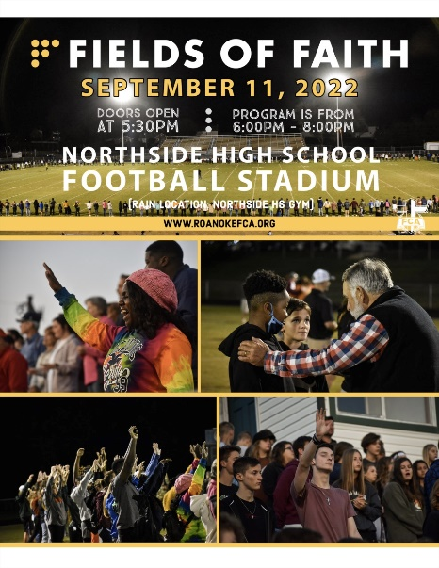

Fields of Faith is an event put on by Fellowship of Christian Athletes. This is a great opportunity for our students to worship with other students from surrounding schools. This year’s speaker is a former Cincinnati Bengal, Anthony Munoz.
Leave- 5pm
Return-8:45pm

Solomon’s Mission is a local Christian non-profit that helps meet physical needs in a number of ways. On November 12th, we will help out with their Saturday lunches (10am-2pm). This is an opportunity to help those in need receive a meal. Typically, each student makes a soup and we serve that soup at the Saturday lunch. This is great opportunity to earn NHS hours as well.
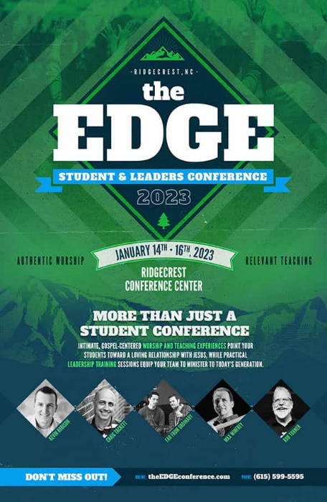

The Edge Conference is our annual winter retreat. This conference is led by Craig Tackett and will be held at Ridgecrest Conference Center in Black Mountain, NC. It is a great time for our students to hear solid preaching and to fellowship with one another. There will be a games and fun activities led by conference.
Dates: Leave- Saturday, January 14th at 10 am
Return- Monday, January 16th at 3pm

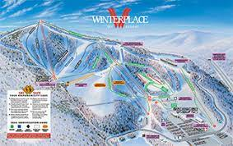
Ski Trip- This is a fun day at Winterplace Resort in West Virginia. Students have the option of skiing, snowboarding, tubing, or relaxing in the lodge where chaperones are always present. There are lessons available to ensure that all students have fun and have a safe day on the slopes.

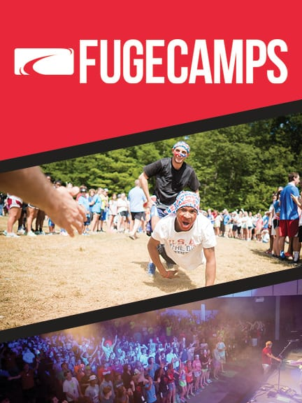
This camp has solid preaching, Bible study times, worship and discipleship along with a lot of fun games and group activities. This camp is a great opportunity for students to grow in their faith while fellowshipping with other students from all across the country.
Typical Schedule: Morning Celebration, Recreation, Quiet Time & Bible study, Lunch, Track times, HangTime, Dinner, Worship, Church Group Time, Night Life.
Track choices: Adventure Rec, Basketball, Battleball, crafts, creative journaling, creative movement, creative painting, Defending Your Faith, Disc Golf, Drama, Flag football, For Girls Only, Games Track, Growing Your Faith, Guitar, Hiking, Kayaking, Kickball, Laser Tag, Lawn games, Leadership 101, Life after Highschool, Mini Golf, Frisbee Games, Paintball, Percussion, Random acts of Service, Sharing your faith, Sign language, Soccer, Softball, Spiritual Gifts, Stem Track, The Man Track, Total Body Fitness, Ultimate Frisbee, Volleyball, Worship Leadership, etc.

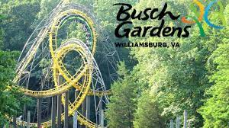
Busch Gardens is an amusement park in Williamsburg, VA. We make an annual trip to Busch Garden’s to enjoy a fun day of riding rollercoasters and fellowship. This year the youth council has decided to go for both Howl O’Scream and for a fun day in the spring. This is a full day event.

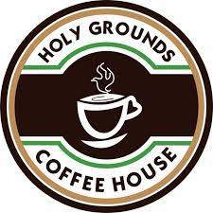
Fundraisers:
Holy Grounds Coffee shop is a great way that our student can fundraise for the various trips and activities throughout the year. Each week two students make coffee during our 8am worship and serve the coffee in between the first worship hour and Sunday school. Students who participate in this activity can have $20 dollars applied to their coffee shop account that can be used for various events throughout the year. To sign up, there is a sign-up sheet posted in the youth room.

Third Sunday Lunch (October 16th)
This October we are going to participate in what is called a third Sunday lunch. These are meals that are sold to the church body on the third Sunday of each month. The proceeds of these meals will be divided among the students who choose to participate.

The Envelope Fundraiser is an opportunity for our students to do a presentation to the church on what we are doing for summer camp. Numbered envelopes are placed in the church and people take them and donate dollars matching the number of the envelope. Last year our students raised over 4,000 dollars for camp.
Our youth council is working to develop a fundraiser for the spring. In the past we have done an envelope fundraiser, a pancake breakfast, etc. If you have any suggestions, please let myself or a member of the youth council know.
There has not been a student who has not been able to go because of cost. When there is financial need above what we raise from fundraisers, scholarships are available to help students cover cost. Please contact Joel for more information.
Event | Date of Event | Cost of Event | Deposit amount/ Due Date | Final Payment
The Edge | 1/14-1/16 | $175 | $75-- 8/31 | $100--- 1/11
Ski Trip | 2/11 | >$150 |  | 2/11
Busch Gardens | 10/22 | >$100 |  | Date of Event
Centrifuge | 7/7-7/11 | $350 | $75—1/31 | $275-- 5/1
Buch Gardens | 4/29 | >$100 |  | Date of Event
Kayaking | TBA | >$50 |  | Date of Event
***If you plan on going to Busch Garden’s in both the fall and spring. Consider getting a season pass or Fun pass. I believe Fun passes are around $110 (please check with Busch Garden’s to make sure that your pass or ticket).

Communication:
- Parent Emails
- Announcements in Sunday School and Wednesday nights
- Remind App
- Church website- has calendars and the annual form
- Monthly Newsletter
- Youth Calendar
- Instagram- @millcreekbaptistyouth
- Weekly Bulletin
***If you feel like you are missing information, please ask! I would love to fill you in on any details you may have missed.
How to sign up for Remind?
Download the remind app and text the following:
Students Parents
Text: @mcbystu Text: @mcbyparent
To: 81010 To: 81010

***Please check app as not all phones send text notifications.

